Karakaj bb, 75400 Zvornik  Republic of Srpska, Bosnia and Herzegovina  Phone: +387 (0) 56 / 260 970, 260 435  Fax: +387 (0) 56 / 260 726  http://www.aluminazv.ba | 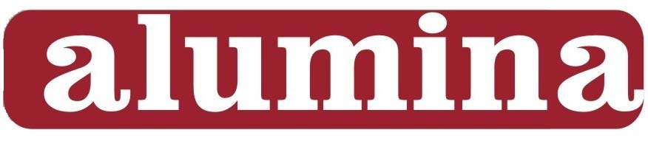  „Alumina” d.o.o.  Zvornik

PRODUCT DATA SHEET

HydrAl 50
Aluminium hydroxide – dried

Main application:Filler for different materials

Chemical Characteristics
Typical content Guaranteed limits
Al₂O₃ | [%] | 65.0 – 65.5 | 64.5 min
SiO₂ | [%] | 0,003 – 0,006 | 0,008 max
Fe₂O₃ | [%] | 0,005 – 0,008 | 0,010 max
Na₂O_{total} | [%] | 0,20 – 0,30 | 0,35 max
CaO | [%] | 0,008 – 0,012 | 0,015 max
CuO | [%] | 0,0010 – 0,0020 | 0,0025 max
TiO₂ | [%] | 0,0013 – 0,0018 | 0,002 max
ZnO | [%] | 0,0008 – 0,012 | 0,015 max

Physical Characteristics
Typical range Guaranteed limits
Moisture (100 °C) | [%] | 0.3 – 0.5 | 1 max
Loss on ignition L.O.I. (1000°C) | [%] | 34 – 35 | 35 max
d_{50%} | [µm] | 45 - 50 | 55 max
> 45 μm (wet sieve) | [%] | 50 - 60 | 65 max
< 12 μm (wet sieve) | [%] | 3.0 – 7.0 | 2.0 min

The above values have been determined by the measuring methods and instruments of Alumina doo Zvornik.

Product is available in bulk, containers or packaged depending on our customer requirements and available for delivery in the following modes of transport:
- Road - bulk and pallets
- Rail - bulk and pallets

Compliance: This product is REACH compliant, ask Alumina doo for the associated REACH
registration details.

